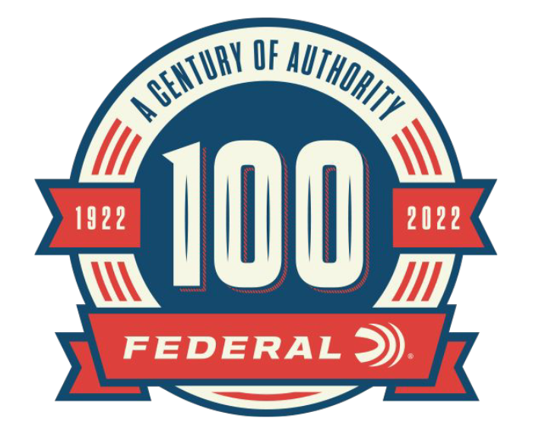

FOR IMMEDIATE RELEASE

Federal Ammunition Joins Rare Companies by Turning 100 Years Old in 2022

ANOKA, Minnesota – January 1, 2022 – Estimates show less than one percent of all companies make it to their 100th year in business. Federal Ammunition joins this extraordinary group in 2022 and has plans to celebrate all year long. Its official date of incorporation was April 27, 1922, but the festivities will start now.

Jason Vanderbrink, Federal’s President offered his thoughts: “The entire staff of 1,500 hard-working Americans in Anoka, Minnesota is extremely proud to celebrate a full century of continuous and successful operation. We appreciate those who came before us to make this possible and look forward to taking Federal into its next century.”

Federal kicks off the year by lighting up a 100th Anniversary sign on top of one its silos in Anoka and will continue to tout its accomplishment with limited availability throwback packaging, special merchandise available on its website, an exhibit at the Anoka County Historical Society Museum and much more.

“Our workforce and business have never been stronger than they are today, and we owe it to a century of continuous innovation across every department in the company. Many people and partners have contributed to our success and I’m proud to join the current team in making sure that tradition of excellence continues.”

A special edition magazine, on your favorite newsstand right now, and coffee table book are also planned, along with many recollections online and via social media of the fun and interesting facts from throughout Federal’s history.
For more information on all products and online services from Federal or to shop online, visit www.federalpremium.com.

Press Release Contact: JJ Reich
Senior Manager – Press Relations
E-mail: VistaPressroom@VistaOutdoor.com
About Federal Ammunition
Federal, headquartered in Anoka, MN, is a brand of Vista Outdoor Inc., an outdoor sports and recreation company. From humble beginnings nestled among the lakes and woods of Minnesota, Federal Ammunition has evolved into one of the world's largest producers of sporting ammunition. Beginning in 1922, founding president, Charles L. Horn, paved the way for our success. Today, Federal carries on Horn's vision for quality products and service with the next generation of outdoorsmen and women. We maintain our position as experts in the science of ammunition production. Every day we manufacture products to enhance our customers' shooting experience while partnering with the conservation organizations that protect and support our outdoor heritage. We offer thousands of options in our Federal Premium and Federal® lines-it's what makes us the most complete ammunition company in the business and provides our customers with a choice no matter their pursuit.

